Artificial Neural Networks

LBYCP29 – Laboratory 8

Gervin Guevarra, Allen Koizumi, Nicholas Moreno, Charleston Uy

Department of Electronics and Communications Engineering

Gokongwei College of Engineering, De La Salle University

Manila, Philippines

*Abstract*—This laboratory experiment serves as an introductory to artificial neural networks, implemented using Python. This sums up the learnings from the previous topics, especially the logistic regression, and forms a cohesive application of the said matter.

Keywords—Neural networks, hidden layers, training, logistic regression

# Introduction

Artificial neural networks is a model widely used for machine intelligence applications and algorithms involving estimation and/or prediction. It is inspired by the biological neurons that comprises our brain, as well the whole nervous system. Neurons in our brain communicate with one another, transferring messages to and fro and processing them to give outputs – “ON” and “OFF”. This binary nature of the outputs of our neurons make it very suitable in computing applications as these also involved two states “1” and “0”. Hence, artificial neural networks essentially works the same way as our biological neurons – forming networks of “cells” that is capable of processing information and consequently produce an output.

Having said that, the foundation of neural networks is the logistic regression as it is very good in dealing with binary classification. In simple terms, neural networks can be thought of as multiple logistic regressions working together to produce an output. Similar with how logistic regression is being implemented, we take into account the hypothesis, the training set, and the costs. Interestingly, artificial neural networks uses the black-box approach – having a layer called hidden layers. In dealing with neural networks, we only concern ourselves with the inputs and corresponding outputs, not with the specific internal workings of the layers.

# Objectives

The experiment aims to achieve the following objectives

* To create a neural network for predicting the exam scores with respect to the number of hours of study and number of hours of sleep;
* To familiarize with the Python language, its paradigms and conventions.

# Data and Results

The following data are the outputs (i.e. array contents and plots) gathered directly from the Python for Parts 3 through 5.

**Part 3**

Out[67]:

array([[ 0.4923282 ],

[ 0.49319418],

[ 0.40674217]])

Out[68]:

array([[ 0.75],

[ 0.82],

[ 0.93]])

Out[69]:

<matplotlib.legend.Legend at 0x783c890>

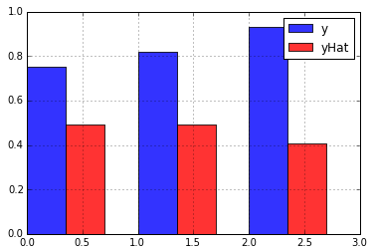

Out[71]:

0.024035226834030254 #time elapsed for 1 weight

Out[72]:

<matplotlib.text.Text at 0x780af70>

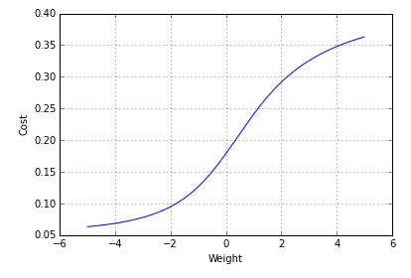

Out[74]:

22.791807189348148 #time elapsed for 2 weight

Out[75]:

1268391679350583.5 #time elapsed (in years) for 9 weights

**Part 4**

Out[5]:

<matplotlib.legend.Legend at 0x103a5d750>

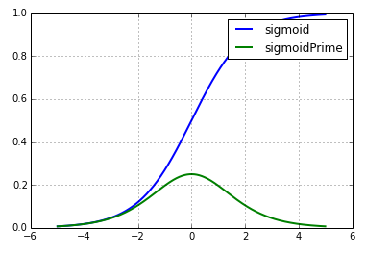

Out[11]:

array([[-0.01903335, -0.00038896, 0.00070959],

[-0.00599893, -0.00011172, 0.00020665]])

Out[12]:

array([[-0.02058574],

[-0.03256431],

[-0.02887828]])

**Part 5**

Out[11]:

(2.9999999999996696, 3.0)

Out[15]:

array([ 0.00108266, 0.00282183, 0.0023393 , 0.00172423, 0.00484326,

0.00358675, 0.00780005, 0.01335848, 0.01554413])

Out[17]:

4.3787229004079797e-10

# Analysis and Conclusion

The concepts used in the experiment were pretty much familiar as it had been encountered previously. However, working with Python adds challenge to the task. Its functions closely resembles that of the Matlab, only that it seems Python is cut for a different job as compared with Matlab.

The lab work is also very similar to logistic regression only that it has some additions for it to be implemented as a neural network.

# Bibliography

|  |  |
| --- | --- |
| [1] | A. Ng, "Spervised Learning," n.d. [Online].  Available: http://cs229.stanford.edu/notes/cs229-notes1.pdf [Accessed 22 September 2015]. |
| [2] | A. Ng, "Machine Learning,"  n.d. [Online]. Available: https://class.coursera.org/ml-003/lecture.  [Accessed 22 September 2015]. |
| [3] | Institute for Digital Research and Edcation, "Stata Data Analysis and  Exampes", 2015 [Online]. Available: http://www.ats.ucla.edu/stat/stata/dae/logit.htm.  [Accessed 22 September 2015]. |